The Islamia University of Bahawalpur
Faculty of computing
Department of Information Technology

Project Software Design Description (SDD)
For
Advanced eCommerce Management System with Integrated Logistics & Marketing
Submitted By
ALI MURTAZA
S23BINFT1M01001
Session SPRING 2023 – 2027

Supervisor
Prof. Dr. Suleman Shah

1.1 Purpose
This Software Design Description (SDD) documents the complete architecture and design of the Advanced eCommerce Management System with Integrated Logistics & Marketing.

1.2 Scope
This document covers system architecture, component design, database schema, API specifications, UI/UX design, security implementation, deployment strategy, data flow, algorithms, error handling, testing, maintenance, performance, and integration.

1.3 Definitions and Acronyms

Term | Definition
API | Application Programming Interface
JWT | JSON Web Token
ORM | Object-Relational Mapping
RBAC | Role-Based Access Control
CDN | Content Delivery Network
AI | Artificial Intelligence
ML | Machine Learning
DFD | Data Flow Diagram
UAT | User Acceptance Testing

1.4 References

Document | Author | Date
Project Proposal | Ali Murtaza | March 25, 2026
Software Requirements Specification | Ali Murtaza | March 25, 2026

1.4 Use Case Diagram

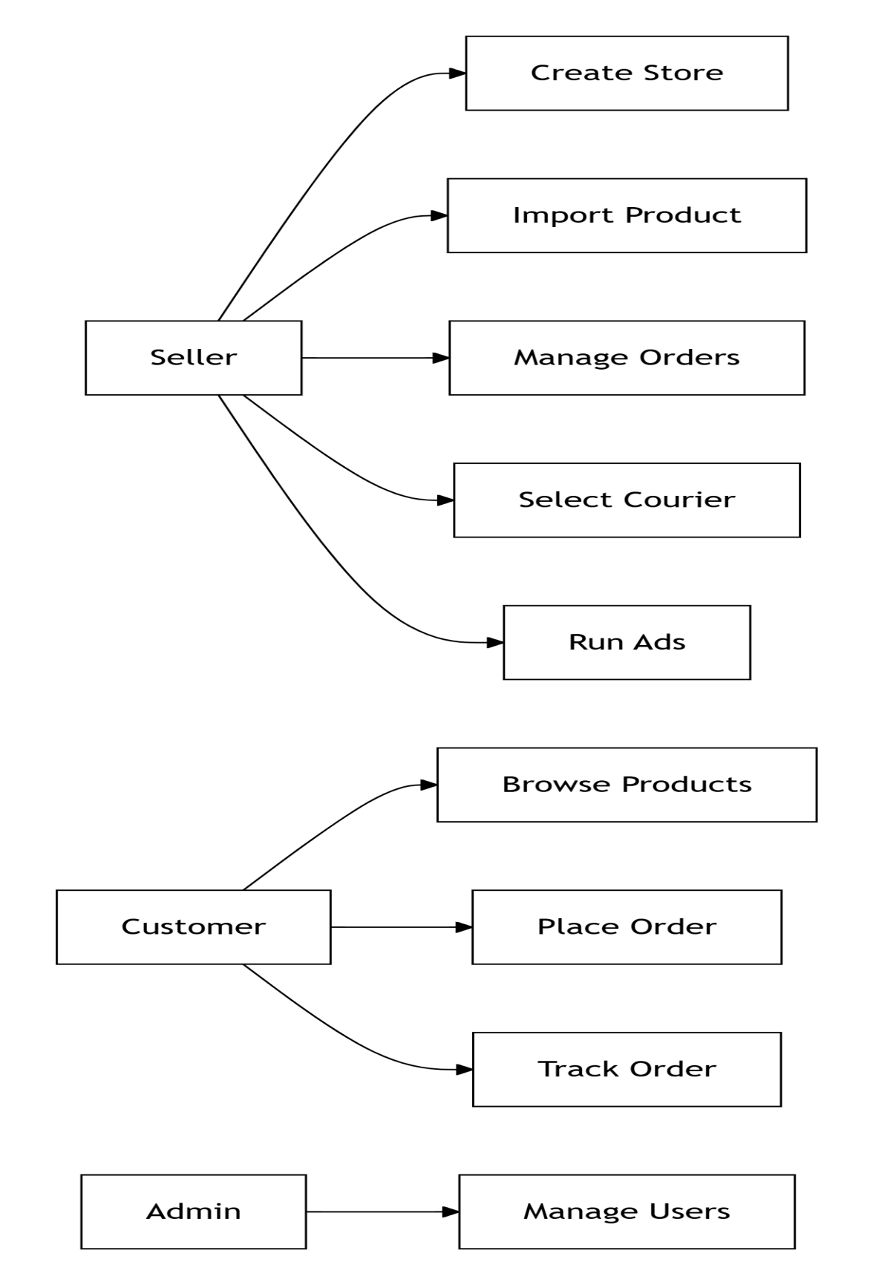

2. System Architecture Design

2.1 Three-Tier Architecture
The system follows a standard three-tier architecture:

Tier | Technology | Responsibility
Presentation Tier | React.js, Tailwind CSS | User interface rendering
Application Tier | Node.js, Express.js | Business logic and API handling
Data Tier | PostgreSQL, Redis, AWS S3 | Data storage and caching

2.2 System Architecture Diagram

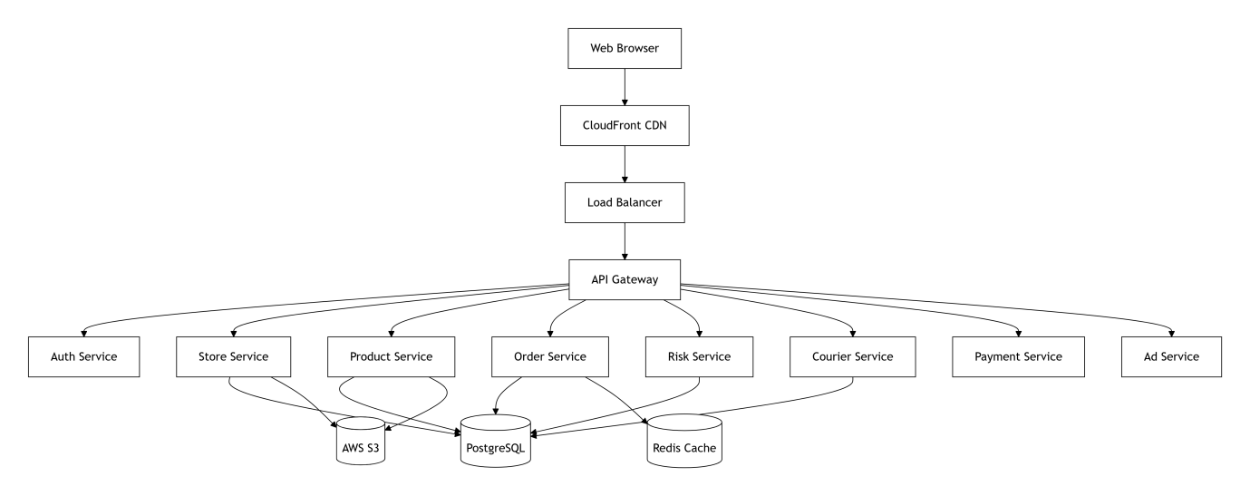

2.3 Technology Stack Summary

Layer | Technology | Purpose
Frontend | React.js, Tailwind CSS, Redux | User interface
Backend | Node.js, Express.js, Sequelize | API and business logic
Database | PostgreSQL | Main data storage
Cache | Redis | Session and real-time data
File Storage | AWS S3 | Images, themes, exports
AI/ML | Python, TensorFlow | Risk scoring, recommendations
Message Queue | RabbitMQ | Async order processing
Container | Docker | Application packaging
Orchestration | Kubernetes | Container management
Cloud Platform | AWS/GCP | Infrastructure

2.4 System Flow Description

Step | Action | Component
1 | User accesses store via browser | CDN + Load Balancer
2 | Request reaches API Gateway | Express Gateway
3 | Authentication check | Auth Service
4 | Request routed to appropriate service | API Gateway
5 | Business logic executed | Respective Service
6 | Data retrieved/stored | Database
7 | Response returned to user | Reverse path

2.5 Architectural Decisions

Decision | Rationale
Microservices over Monolith | Better scalability and independent deployment
Node.js for Backend | Fast I/O, large ecosystem, suitable for real-time
PostgreSQL over MySQL | Better JSON support, ACID compliance
Redis for Caching | In-memory storage, fast response times
Kubernetes for Orchestration | Auto-scaling, self-healing, rolling updates

3. Component Design

3.1 Core Modules Description

Module Name | Files | Description
Store Builder | store.js, theme.js, editor.js | Create, customize, and publish online store
Product Import | import.js, scraper.js, extractor.js | 1-click product import from any URL
Customer Risk Engine | risk.js, scoring.js, flags.js | AI-based customer risk scoring
Courier Integration | courier.js, tracking.js, label.js | Multi-courier API integration
AI Courier Recommender | ai/courier.js, ai/prediction.js | ML-based courier suggestions
Payment Processing | payment.js, gateway.js | Stripe/PayPal integration
Ad Management | ads/meta.js, ads/tiktok.js | Meta and TikTok ads integration
Central Dashboard | dashboard.js, analytics.js | Unified seller dashboard
Admin Panel | admin/users.js, admin/stores.js | Platform administration

3.2 Component Diagram

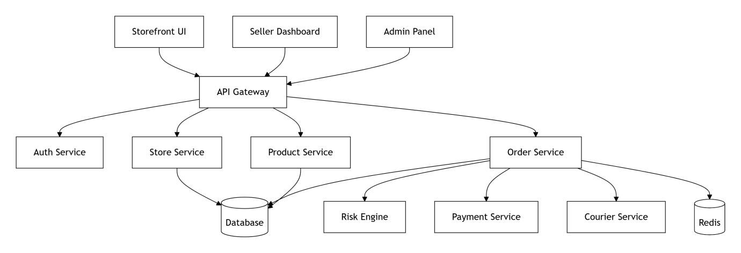

3.3 Module Interactions

Sender Module | Receiver Module | Communication Method | Sync/Async
Client Browser | API Gateway | HTTPS / REST | Synchronous
API Gateway | Auth Service | HTTP / JWT | Synchronous
API Gateway | Store Service | HTTP / REST | Synchronous
Order Service | Risk Service | RabbitMQ | Asynchronous
Order Service | Payment Service | HTTP / REST | Synchronous
Order Service | Courier Service | RabbitMQ | Asynchronous
Courier Service | External APIs | HTTP / REST | Synchronous
Payment Service | Stripe/PayPal | HTTP / REST | Synchronous
Ad Service | Meta/TikTok | HTTP / REST | Synchronous

3.4 Module Dependencies

Module | Depends On
Store Service | Database, Auth Service
Product Service | Database, Store Service
Order Service | Database, Product Service, Risk Service
Risk Service | Database, AI Engine
Courier Service | Database, External APIs
Payment Service | Database, Stripe/PayPal
Ad Service | Database, Meta/TikTok APIs

4. Database Design

4.1 Entity Relationship Overview

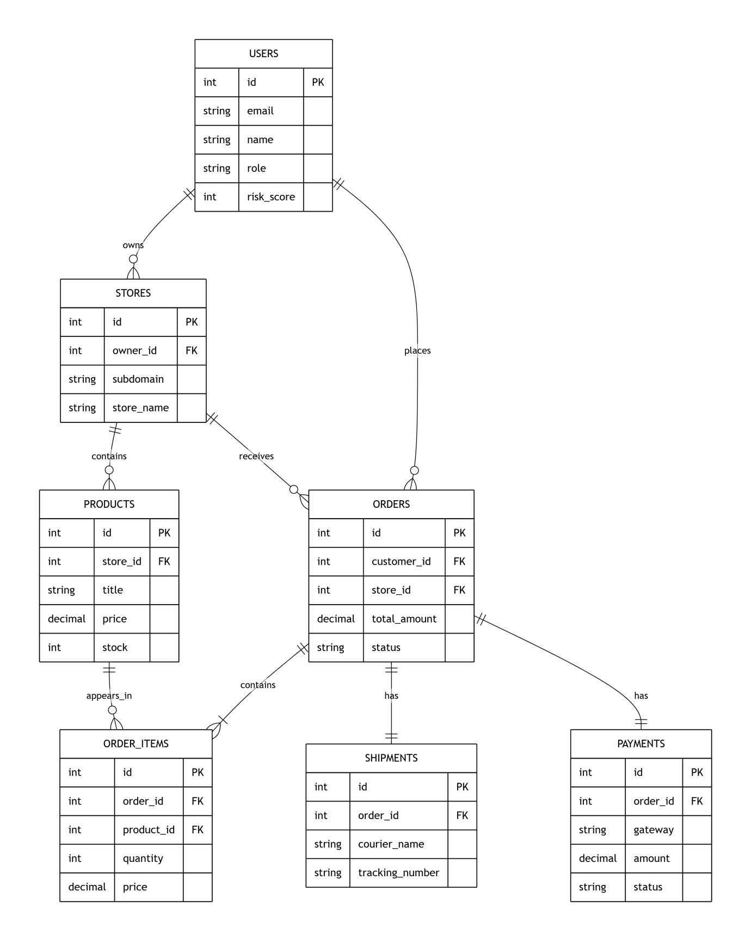

4.2 Entity Relationship Overview

Entity | Description | Relationships
users | System users (sellers, customers, admins) | One-to-many with stores and orders
stores | Seller stores | One-to-many with products and orders
products | Store products | Many-to-one with stores
orders | Customer orders | Many-to-one with users and stores
order_items | Line items in orders | Many-to-one with orders and products
shipments | Shipping details | One-to-one with orders
payments | Payment transactions | One-to-one with orders
courier_performance | Courier analytics | Lookup table
ad_campaigns | Ad campaigns | Many-to-one with stores

4.3 Table: users

Column Name | Data Type | Constraints | Description
id | SERIAL | PRIMARY KEY | Unique user identifier
email | VARCHAR(255) | UNIQUE, NOT NULL | User email address
password_hash | VARCHAR(255) | NOT NULL | Hashed password
name | VARCHAR(100) | NOT NULL | Full name
phone | VARCHAR(20) | NULL | Contact number
role | ENUM | DEFAULT 'customer' | admin, seller, customer
risk_score | INT | DEFAULT 0 | Risk score (0-100)
is_blocked | BOOLEAN | DEFAULT FALSE | Account blocked status
created_at | TIMESTAMP | DEFAULT NOW() | Account creation date
updated_at | TIMESTAMP | DEFAULT NOW() | Last update date

4.4 Table: stores

Column Name | Data Type | Constraints | Description
id | SERIAL | PRIMARY KEY | Unique store identifier
owner_id | INT | FOREIGN KEY → users.id | Store owner
subdomain | VARCHAR(100) | UNIQUE, NOT NULL | Store subdomain
custom_domain | VARCHAR(255) | NULL | Custom domain name
store_name | VARCHAR(200) | NOT NULL | Store display name
logo_url | TEXT | NULL | Store logo URL
theme_id | INT | NOT NULL | Active theme ID
currency | VARCHAR(3) | DEFAULT 'USD' | Store currency
status | ENUM | DEFAULT 'active' | active, suspended
created_at | TIMESTAMP | DEFAULT NOW() | Store creation date

4.5 Table: products

Column Name | Data Type | Constraints | Description
id | SERIAL | PRIMARY KEY | Unique product identifier
store_id | INT | FOREIGN KEY → stores.id | Parent store
title | VARCHAR(500) | NOT NULL | Product title
description | TEXT | NULL | Product description
price | DECIMAL(10,2) | NOT NULL | Selling price
compare_price | DECIMAL(10,2) | NULL | Original price
cost_price | DECIMAL(10,2) | NULL | Cost price
stock | INT | DEFAULT 0 | Available quantity
images | TEXT[] | NULL | Array of image URLs
source_url | TEXT | NULL | Import source URL
status | ENUM | DEFAULT 'active' | active, draft, archived
created_at | TIMESTAMP | DEFAULT NOW() | Product creation date

4.6 Table: orders

Column Name | Data Type | Constraints | Description
id | SERIAL | PRIMARY KEY | Unique order identifier
order_number | VARCHAR(50) | UNIQUE, NOT NULL | Human readable order ID
customer_id | INT | FOREIGN KEY → users.id | Customer who placed order
store_id | INT | FOREIGN KEY → stores.id | Store receiving order
subtotal | DECIMAL(10,2) | NOT NULL | Order subtotal
shipping_cost | DECIMAL(10,2) | DEFAULT 0 | Shipping charges
tax | DECIMAL(10,2) | DEFAULT 0 | Tax amount
total_amount | DECIMAL(10,2) | NOT NULL | Final order total
status | ENUM | DEFAULT 'pending' | pending, paid, shipped, delivered, cancelled
shipping_address | TEXT | NOT NULL | Delivery address
billing_address | TEXT | NOT NULL | Billing address
notes | TEXT | NULL | Order notes
created_at | TIMESTAMP | DEFAULT NOW() | Order date

4.7 Table: order_items

Column Name | Data Type | Constraints | Description
id | SERIAL | PRIMARY KEY | Unique identifier
order_id | INT | FOREIGN KEY → orders.id | Parent order
product_id | INT | FOREIGN KEY → products.id | Product ordered
quantity | INT | NOT NULL | Quantity ordered
price | DECIMAL(10,2) | NOT NULL | Price at order time
total | DECIMAL(10,2) | NOT NULL | Line item total

4.8 Table: shipments

Column Name | Data Type | Constraints | Description
id | SERIAL | PRIMARY KEY | Unique shipment identifier
order_id | INT | FOREIGN KEY → orders.id | Associated order
courier_name | VARCHAR(100) | NOT NULL | Courier service name
courier_code | VARCHAR(50) | NULL | Courier API code
tracking_number | VARCHAR(100) | NULL | Tracking number
tracking_url | TEXT | NULL | Tracking link
status | VARCHAR(50) | DEFAULT 'pending' | pending, picked, in_transit, delivered, returned
estimated_delivery | DATE | NULL | Expected delivery date
actual_delivery | DATE | NULL | Actual delivery date
shipping_cost | DECIMAL(10,2) | NOT NULL | Shipping cost paid
label_url | TEXT | NULL | Shipping label URL
created_at | TIMESTAMP | DEFAULT NOW() | Shipment creation date

4.9 Table: payments

Column Name | Data Type | Constraints | Description
id | SERIAL | PRIMARY KEY | Unique payment identifier
order_id | INT | FOREIGN KEY → orders.id | Associated order
gateway | VARCHAR(50) | NOT NULL | stripe, paypal, local
transaction_id | VARCHAR(255) | UNIQUE | Gateway transaction ID
amount | DECIMAL(10,2) | NOT NULL | Payment amount
currency | VARCHAR(3) | DEFAULT 'USD' | Currency code
status | VARCHAR(50) | DEFAULT 'pending' | pending, success, failed, refunded
payment_method | VARCHAR(50) | NULL | card, bank, wallet
metadata | JSONB | NULL | Additional payment data
created_at | TIMESTAMP | DEFAULT NOW() | Payment date

4.10 Table: courier_performance

Column Name | Data Type | Constraints | Description
id | SERIAL | PRIMARY KEY | Unique identifier
courier_name | VARCHAR(100) | NOT NULL | Courier name
city | VARCHAR(100) | NOT NULL | Destination city
success_rate | FLOAT | DEFAULT 0 | Delivery success percentage
avg_delivery_days | FLOAT | DEFAULT 0 | Average delivery time in days
avg_cost | DECIMAL(10,2) | DEFAULT 0 | Average shipping cost
total_orders | INT | DEFAULT 0 | Number of orders processed
last_updated | TIMESTAMP | DEFAULT NOW() | Last update timestamp

4.11 Table: ad_campaigns

Column Name | Data Type | Constraints | Description
id | SERIAL | PRIMARY KEY | Unique campaign identifier
store_id | INT | FOREIGN KEY → stores.id | Associated store
platform | VARCHAR(50) | NOT NULL | meta, tiktok
campaign_id_ext | VARCHAR(255) | NOT NULL | External platform campaign ID
name | VARCHAR(255) | NOT NULL | Campaign name
budget | DECIMAL(10,2) | NOT NULL | Daily budget
spent | DECIMAL(10,2) | DEFAULT 0 | Total spent
impressions | INT | DEFAULT 0 | Ad impressions
clicks | INT | DEFAULT 0 | Ad clicks
conversions | INT | DEFAULT 0 | Conversions
revenue | DECIMAL(10,2) | DEFAULT 0 | Revenue generated
roas | FLOAT | DEFAULT 0 | Return on ad spend
status | VARCHAR(50) | DEFAULT 'active' | active, paused, ended
last_synced | TIMESTAMP | DEFAULT NOW() | Last sync with platform

4.12 Indexing Strategy

Table | Column | Index Type | Purpose
users | email | B-Tree | Fast login lookups
stores | owner_id | B-Tree | Store queries by owner
products | store_id | B-Tree | Product listing by store
orders | customer_id | B-Tree | Customer order history
orders | store_id | B-Tree | Store order list
orders | status | B-Tree | Status filtering
shipments | tracking_number | Hash | Fast tracking lookups

5. API Design

5.1 API Design Principles

Principle | Description
RESTful | Follow REST conventions for all endpoints
Stateless | Each request contains all necessary information
JSON Format | All requests and responses use JSON
Versioning | API version included in URL (/api/v1/)
HTTP Status Codes | Standard HTTP status codes for responses

5.2 Authentication APIs

Method | Endpoint | Description | Auth Required
POST | /api/v1/auth/register | Register new user account | No
POST | /api/v1/auth/login | Login and receive JWT token | No
POST | /api/v1/auth/logout | Invalidate current session | Yes
POST | /api/v1/auth/refresh | Refresh expired JWT token | Yes
GET | /api/v1/auth/me | Get current user profile | Yes
PUT | /api/v1/auth/me | Update user profile | Yes
POST | /api/v1/auth/change-password | Change user password | Yes
POST | /api/v1/auth/forgot-password | Request password reset | No
POST | /api/v1/auth/reset-password | Reset password with token | No

5.3 Store Management APIs

Method | Endpoint | Description | Auth Required
POST | /api/v1/stores | Create new store | Yes (Seller)
GET | /api/v1/stores | Get all stores for user | Yes
GET | /api/v1/stores/:id | Get store details | Yes
PUT | /api/v1/stores/:id | Update store information | Yes (Owner)
DELETE | /api/v1/stores/:id | Delete store | Yes (Owner)
POST | /api/v1/stores/:id/publish | Publish store to subdomain | Yes (Owner)
PUT | /api/v1/stores/:id/theme | Change store theme | Yes (Owner)
GET | /api/v1/stores/:id/stats | Get store analytics | Yes (Owner)

5.4 Product Management APIs

Method | Endpoint | Description | Auth Required
POST | /api/v1/products/import | 1-click import from URL | Yes (Seller)
GET | /api/v1/products | List all products with filters | Yes
POST | /api/v1/products | Add product manually | Yes (Seller)
GET | /api/v1/products/:id | Get product details | Yes
PUT | /api/v1/products/:id | Update product | Yes (Seller)
DELETE | /api/v1/products/:id | Delete product | Yes (Seller)
PUT | /api/v1/products/:id/stock | Update inventory quantity | Yes (Seller)
POST | /api/v1/products/bulk-import | Bulk import products | Yes (Seller)

5.5 Order Management APIs

Method | Endpoint | Description | Auth Required
GET | /api/v1/orders | Get all orders with filters | Yes
GET | /api/v1/orders/:id | Get order details | Yes
PUT | /api/v1/orders/:id/status | Update order status | Yes (Seller)
GET | /api/v1/orders/:id/risk | Get customer risk score | Yes (Seller)
POST | /api/v1/orders/:id/cancel | Cancel order | Yes
GET | /api/v1/orders/:id/invoice | Download order invoice | Yes

5.6 Shipping and Courier APIs

Method | Endpoint | Description | Auth Required
GET | /api/v1/couriers | List all available couriers | Yes
GET | /api/v1/couriers/rates | Get shipping rate quotes | Yes
POST | /api/v1/couriers/ship | Create new shipment | Yes (Seller)
GET | /api/v1/couriers/track/:id | Track shipment | Yes
GET | /api/v1/couriers/recommend | Get AI courier recommendation | Yes (Seller)
GET | /api/v1/couriers/performance | Get courier performance stats | Yes (Seller)

5.7 Payment APIs

Method | Endpoint | Description | Auth Required
POST | /api/v1/payments/create-intent | Create payment intent | Yes
GET | /api/v1/payments/:id | Get payment status | Yes
POST | /api/v1/payments/webhook | Webhook for gateway callbacks | No
POST | /api/v1/payments/:id/refund | Refund payment | Yes (Seller)

5.8 Marketing and Ads APIs

Method | Endpoint | Description | Auth Required
POST | /api/v1/ads/connect | Connect ad platform account | Yes (Seller)
GET | /api/v1/ads/metrics | Get campaign performance metrics | Yes (Seller)
POST | /api/v1/ads/campaign | Create new ad campaign | Yes (Seller)
PUT | /api/v1/ads/campaign/:id | Update campaign | Yes (Seller)
POST | /api/v1/ads/campaign/:id/pause | Pause active campaign | Yes (Seller)
POST | /api/v1/ads/campaign/:id/resume | Resume paused campaign | Yes (Seller)
DELETE | /api/v1/ads/campaign/:id | Delete campaign | Yes (Seller)

5.9 API Response Format
Success Response Structure:

Field | Type | Description
success | boolean | Always true for success
data | object or array | Response data
message | string | Optional success message

Error Response Structure:

Field | Type | Description
success | boolean | Always false for error
error | string | Error code
message | string | Human readable error message
details | array | Optional validation details

5.10 HTTP Status Codes

Status Code | Meaning | Usage
200 | OK | Successful request
201 | Created | Resource successfully created
400 | Bad Request | Invalid input data
401 | Unauthorized | Missing or invalid authentication
403 | Forbidden | Authenticated but not authorized
404 | Not Found | Resource does not exist
422 | Unprocessable Entity | Validation failed
429 | Too Many Requests | Rate limit exceeded
500 | Internal Server Error | Server side error

6. UI/UX Design

6.1 Screen Inventory

Screen Name | User Type | Description
Login / Signup | All | User authentication entry point
Seller Dashboard | Seller | Overview of sales, orders, and metrics
Store Builder | Seller | Theme selection and store customization
Product Manager | Seller | Add, edit, delete, import products
Order Manager | Seller | View and process customer orders
Shipping Center | Seller | Courier selection and label printing
Marketing Hub | Seller | Ad campaign management
Analytics | Seller | Sales reports and insights
Settings | Seller | Store configuration
Customer Storefront | Customer | Product browsing and checkout
Admin Panel | Admin | User and platform management

6.2 Navigation Structure

Level | Navigation Items
Main Navigation | Dashboard, Store Builder, Products, Orders, Shipping, Marketing, Analytics, Settings
Products Sub Navigation | All Products, Add Product, Import Product (1-Click), Categories, Inventory
Orders Sub Navigation | All Orders, Pending Orders, Shipped Orders, Delivered Orders, Cancelled Orders
Shipping Sub Navigation | Create Shipment, Track Shipment, Courier Comparison, AI Recommendations, Performance Reports

6.3 Color Scheme

Element Type | Color Name | Hex Code | Usage
Primary | Blue | 3B82F6 | Buttons, links, active states
Secondary | Purple | 8B5CF6 | Accents, highlights
Success | Green | 10B981 | Paid, delivered, confirmed
Warning | Yellow | F59E0B | Pending, processing, caution
Danger | Red | EF4444 | Failed, cancelled, errors
Info | Cyan | 06B6D4 | Information, tips
Dark Text | Dark Gray | 1F2937 | Headings, primary text
Light Text | Gray | 6B7280 | Labels, secondary text
Background | White | FFFFFF | Main background

6.4 Typography

Text Type | Font | Size | Weight | Usage
Heading 1 | Inter | 32px | Bold | Page titles
Heading 2 | Inter | 24px | Semi-bold | Section headers
Heading 3 | Inter | 20px | Semi-bold | Card titles
Body Text | Inter | 16px | Regular | Paragraphs
Small Text | Inter | 14px | Regular | Labels, meta
Button Text | Inter | 16px | Medium | Buttons

6.5 Responsive Breakpoints

Breakpoint | Screen Width | Layout
Mobile | Less than 640px | Single column, hamburger menu
Tablet | 640px to 1024px | Two columns, sidebar collapsible
Desktop | Greater than 1024px | Full layout, multiple columns
Wide | Greater than 1440px | Expanded layout, maximum width

7. Security Design

7.1 Authentication and Authorization

Security Feature | Implementation | Description
Password Hashing | bcrypt (10 rounds) | One-way encryption of passwords
Session Management | JWT (24 hour expiry) | Stateless authentication tokens
Two-Factor Authentication | TOTP (Google Authenticator) | Optional 2FA for sellers
Role Based Access | RBAC with 3 roles | Admin, Seller, Customer
Account Lockout | After 5 failed attempts | Prevents brute force attacks
Password Policy | Minimum 8 chars, 1 number, 1 special | Strong password enforcement

7.2 Data Security

Data Type | Protection Method | Storage Location
User Passwords | bcrypt hash | PostgreSQL
Personal Information | AES-256 encryption | PostgreSQL
Payment Information | Handled by gateway (PCI compliant) | Stripe or PayPal
API Keys | Environment variables and Vault | AWS Secrets Manager
Product Images | Public with signed URLs | AWS S3
Database Backups | AES-256 encrypted | AWS S3 (30 day retention)

7.3 API Security

Security Measure | Implementation | Protection Against
Rate Limiting | 100 requests per minute per IP | DDoS, brute force
CORS | Whitelisted domains only | Cross-origin attacks
Input Validation | Joi or Express-validator | Injection attacks
SQL Injection Prevention | Parameterized queries | SQL injection
XSS Protection | Helmet.js, sanitize HTML | Cross-site scripting
CSRF Protection | CSRF tokens | Cross-site request forgery
HTTPS | TLS 1.2+ for all traffic | Man-in-the-middle

7.4 Security Roles and Permissions

Permission | Admin | Seller | Customer
Manage all users | Yes | No | No
Approve or block stores | Yes | No | No
Manage own store | No | Yes | No
Add or edit products | No | Yes | No
Process orders | No | Yes | No
View own orders | No | Yes | Yes
Place orders | No | No | Yes
Manage ad campaigns | No | Yes | No
View analytics | No | Yes | No
Update own profile | Yes | Yes | Yes

7.5 Security Headers

Header | Value | Purpose
Strict-Transport-Security | max-age=31536000 | Enforce HTTPS
X-Content-Type-Options | nosniff | Prevent MIME sniffing
X-Frame-Options | DENY | Prevent clickjacking
X-XSS-Protection | 1; mode=block | XSS protection
Content-Security-Policy | default-src 'self' | Control resource loading
Referrer-Policy | strict-origin-when-cross-origin | Control referrer info

7.6 Audit Logging

Event | Logged Data | Retention
Login attempts | IP, timestamp, success or failure | 90 days
Order creation | User ID, order ID, amount | 90 days
Payment processing | Transaction ID, amount, status | 90 days
Product changes | User ID, product ID, change type | 90 days
Setting changes | User ID, setting name, old and new value | 90 days
Admin actions | Admin ID, action, target | 365 days

8. Deployment Design

8.1 Deployment Diagram

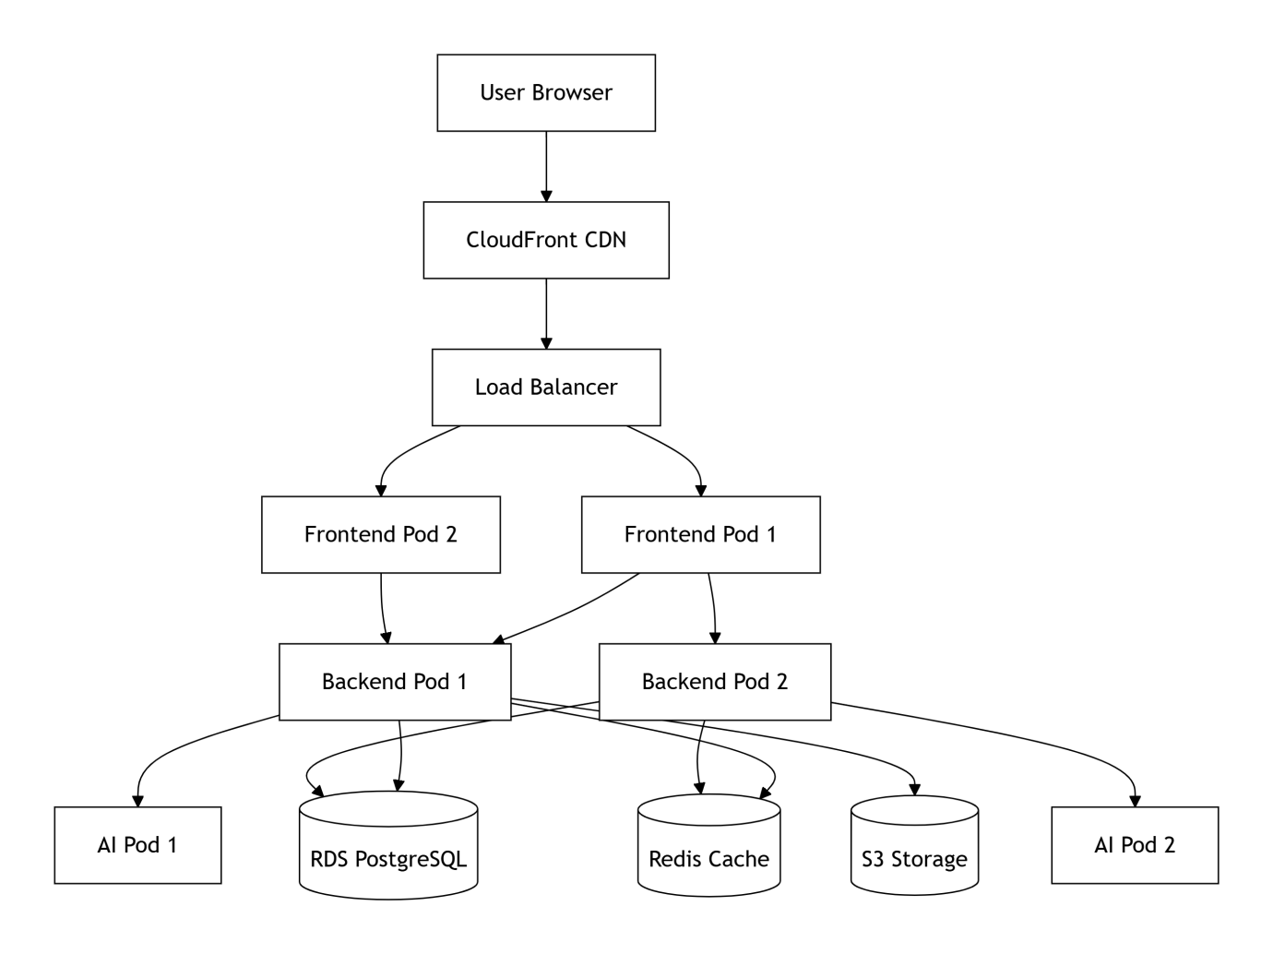

8.2 Environment Configuration

Environment | Purpose | URL | Auto Deploy
Development | Active development | dev.platform.com | On push to dev branch
Staging | Testing and QA | staging.platform.com | On push to staging branch
Production | Live platform | platform.com | On push to main branch

8.3 CI/CD Pipeline

Stage | Action | Tool
1 | Code commit | GitHub
2 | Run unit tests | Jest
3 | Run integration tests | Supertest
4 | Build Docker images | Docker
5 | Push to container registry | ECR
6 | Deploy to Kubernetes | kubectl
7 | Run smoke tests | Postman
8 | Notify team | Slack

8.4 Scaling Configuration

Component | Minimum Pods | Maximum Pods | CPU Threshold
Frontend | 2 | 10 | 70 percent
Backend API | 3 | 15 | 70 percent
AI Service | 2 | 8 | 80 percent
Database | 1 (Multi-AZ) | Not Applicable | Auto-scaling storage

8.5 Monitoring and Alerting

Tool | Purpose | Metrics
Prometheus | Metrics collection | CPU, memory, request rate
Grafana | Visualization | Dashboards, graphs
ELK Stack | Log aggregation | Error logs, access logs
Sentry | Error tracking | Application exceptions
Uptime Robot | Availability | 5 minute interval checks

8.6 Backup and Disaster Recovery

Component | Backup Frequency | Retention | Recovery Time
PostgreSQL | Daily | 30 days | Less than 4 hours
Redis | Daily | 7 days | Less than 1 hour
AWS S3 | Continuous | Not Applicable | Instant
Configuration | On each change | 90 days | Less than 1 hour

9. Data Flow Design

9.1 Order Processing Flow

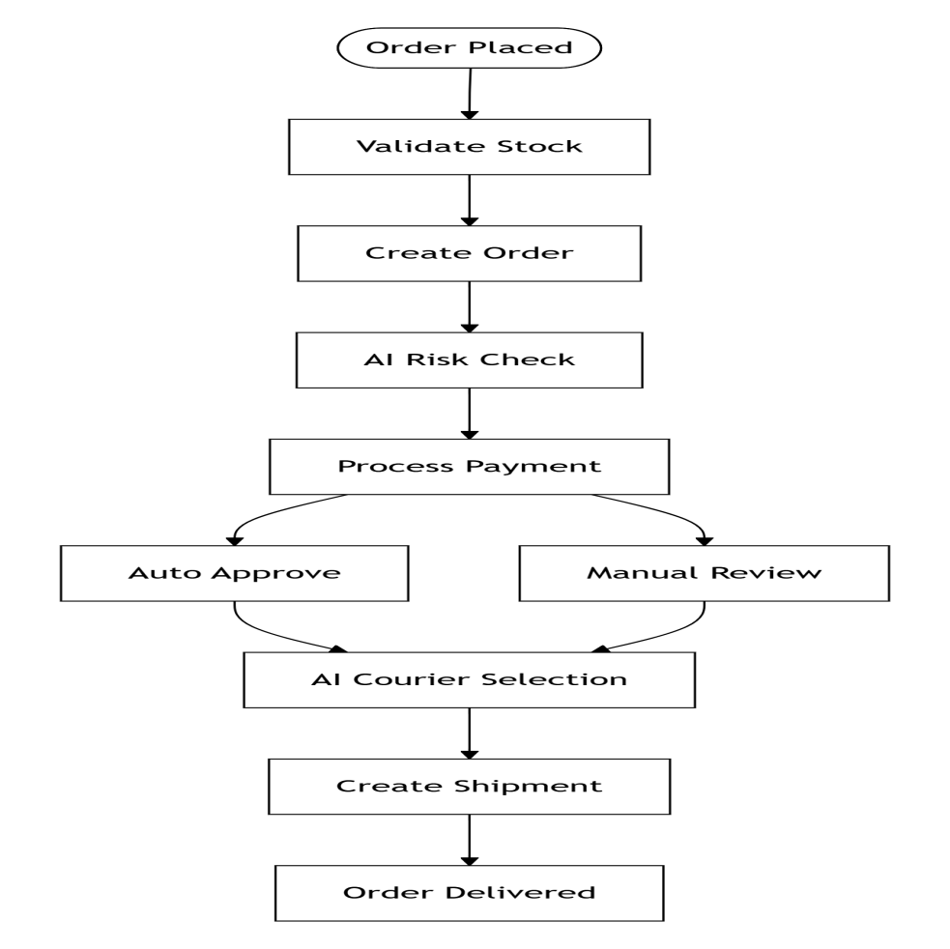

9.2 Order Processing Flow

Step | Action | Component
1 | Customer places order | Storefront
2 | API Gateway receives request | API Gateway
3 | Order Service validates stock | Order Service
4 | Order Service creates order | Order Service
5 | Risk Service calculates customer risk | Risk Service
6 | Payment Service processes payment | Payment Service
7 | If low risk, order auto approved | Order Service
8 | If high risk, order flagged for manual review | Order Service
9 | Courier Service creates shipment | Courier Service
10 | Tracking number generated | Courier Service
11 | Customer notified | Notification Service

9.3 Product Import Flow

Step | Action | Component
1 | Seller pastes product URL | Product Manager UI
2 | API Gateway routes to Product Service | API Gateway
3 | System fetches HTML content | Product Service
4 | System extracts title, price, images | Product Service
5 | Preview shown to seller | Product Manager UI
6 | Seller confirms or edits | Product Manager UI
7 | Product saved to database | Product Service
8 | Seller notified of completion | Notification Service

9.4 Sequence Diagram

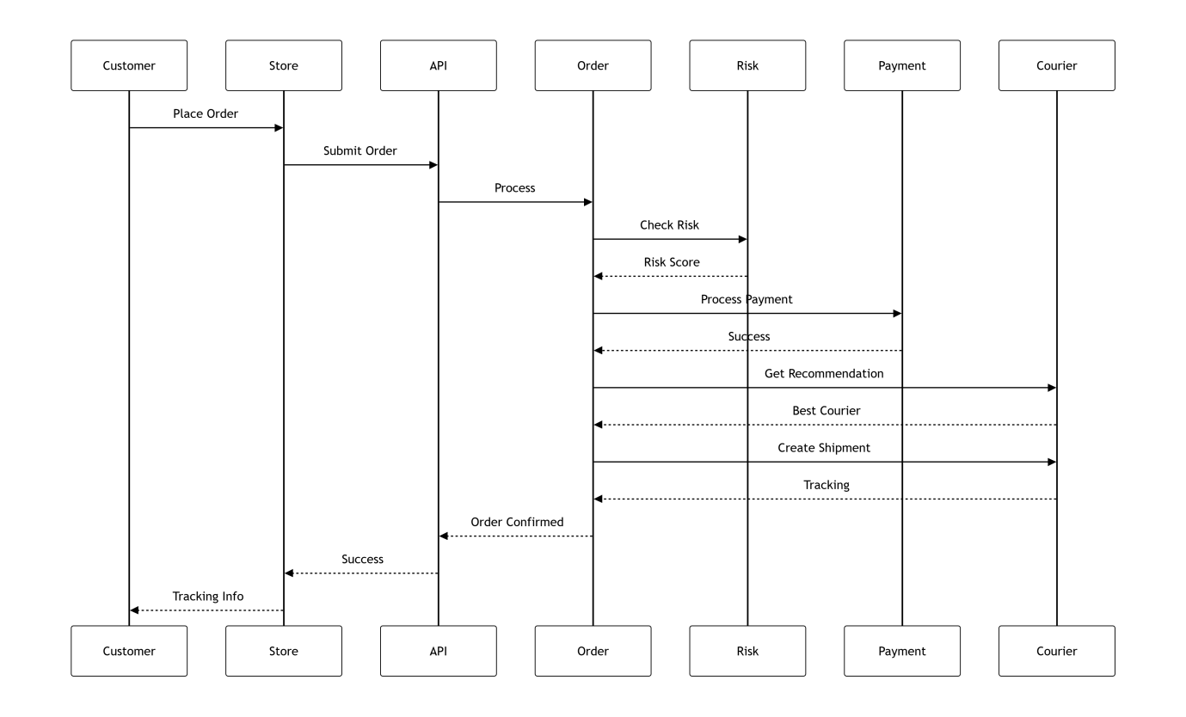

9.5 AI Courier Recommendation Flow

Step | Action | Component
1 | Order created | Order Service
2 | Courier Service gets order details | Courier Service
3 | System fetches courier performance data | Database
4 | AI model processes historical data | AI Engine
5 | Each courier gets score based on metrics | AI Engine
6 | Couriers ranked by score | AI Engine
7 | Top recommendation returned to seller | Courier Service

10. Algorithm Design

10.1 Customer Risk Scoring Algorithm

Step | Process | Weight
1 | Count total orders placed by customer | 10 percent
2 | Count cancelled orders | 25 percent
3 | Count returned orders | 30 percent
4 | Count payment failures | 25 percent
5 | Count fake order reports | 15 percent
6 | Calculate time since last order | Minus 5 percent if recent
7 | Calculate risk score equals sum of weighted factors | Not Applicable
8 | If score greater than 70 then High Risk | Not Applicable
9 | If score between 31 and 70 then Medium Risk | Not Applicable
10 | If score less than 30 then Low Risk | Not Applicable

10.2 Courier Recommendation Algorithm

Step | Process | Weight
1 | Get destination city from order | Not Applicable
2 | Fetch all couriers serving that city | Not Applicable
3 | Calculate success rate score from 0 to 100 | 40 percent
4 | Calculate delivery time score from 0 to 100 | 35 percent
5 | Calculate cost score from 0 to 100 | 25 percent
6 | Total score equals success times 0.4 plus time times 0.35 plus cost times 0.25 | Not Applicable
7 | Sort couriers by total score descending | Not Applicable
8 | Return top 3 recommendations | Not Applicable

10.3 Delivery Time Prediction Algorithm

Step | Process
1 | Get courier historical data for city
2 | Get current day of week
3 | Check for holidays in next 7 days
4 | Calculate base delivery days equals historical average
5 | Add weekend adjustment (plus 2 days if weekend)
6 | Add holiday adjustment (plus 1 day per holiday)
7 | Return predicted delivery date equals today plus adjusted days

11. Error Handling Design

11.1 Error Types and Responses

Error Type | HTTP Code | Action
Validation Error | 422 | Return field-specific error messages
Authentication Error | 401 | Redirect to login page
Authorization Error | 403 | Show Access Denied message
Not Found Error | 404 | Show custom 404 page
Server Error | 500 | Log error, show generic message
Rate Limit Error | 429 | Show Too Many Requests message
Payment Error | 400 | Show payment failure reason
Courier API Error | 502 | Retry with backup courier

11.2 Logging Strategy

Log Level | Usage | Example
ERROR | System failures, exceptions | Database connection failed
WARN | Potential issues | Payment gateway timeout
INFO | Normal operations | Order number 123 created
DEBUG | Development debugging | API request payload
TRACE | Detailed flow tracking | Function entry and exit

11.3 Retry Mechanism

Operation | Maximum Retries | Delay in Milliseconds | Backoff Type
Payment Processing | 3 | 1000 | Exponential
Courier API Call | 2 | 500 | Linear
Email Sending | 3 | 2000 | Exponential
Webhook Delivery | 5 | 1000 | Exponential

12. Testing Design

12.1 Testing Levels

Level | Description | Tools
Unit Testing | Test individual functions | Jest, Mocha
Integration Testing | Test API endpoints | Supertest
Component Testing | Test React components | React Testing Library
End-to-End Testing | Test user workflows | Cypress, Selenium
Performance Testing | Load and stress testing | K6, JMeter
Security Testing | Vulnerability scanning | OWASP ZAP

12.2 Test Coverage Requirements

Component | Required Coverage
Backend API | 80 percent
Frontend Components | 70 percent
AI Models | 90 percent
Database Queries | 75 percent
Security Modules | 100 percent

12.3 Test Cases for Key Features

Feature | Test Case | Expected Result
User Registration | Valid email and password | Account created
User Registration | Duplicate email | Error returned
Product Import | Valid product URL | Data extracted
Product Import | Invalid URL | Error message
Risk Scoring | Customer with 5 returns | High risk score
Payment Processing | Valid card | Success response
Courier Selection | City with data | Recommendations returned
Order Creation | Insufficient stock | Error returned

13. Maintenance Design

13.1 Maintenance Types

Type | Description | Frequency
Corrective | Fix bugs and errors | As needed
Adaptive | Update for new APIs | Quarterly
Perfective | Performance improvements | Monthly
Preventive | Security updates | Weekly

13.2 Backup Schedule

Component | Full Backup | Incremental | Retention
Database | Daily at 2 AM | Every 6 hours | 30 days
User Files | Daily at 3 AM | None | 90 days
Logs | Daily at 4 AM | None | 90 days
Configuration | On each change | None | 365 days

13.3 Update Procedure

Step | Action | Responsible
1 | Create backup | DevOps
2 | Deploy to staging | DevOps
3 | Run regression tests | QA
4 | Get approval | Project Manager
5 | Deploy to production | DevOps
6 | Monitor for errors | All team members
7 | Rollback if needed | DevOps

14. Performance Design

14.1 Performance Targets

Metric | Target | Measurement
Page Load Time | Less than 3 seconds | Browser DevTools
API Response Time | Less than 500 milliseconds | Postman or New Relic
Concurrent Users | 1000 | Load testing
Database Query | Less than 100 milliseconds | Slow query log
Search Results | Less than 1 second | Performance monitoring

14.2 Optimization Techniques

Area | Technique | Expected Improvement
Frontend | Lazy loading, code splitting | 40 percent faster load
Backend | Caching with Redis | 60 percent faster response
Database | Indexing, query optimization | 50 percent faster queries
Images | CDN, compression | 70 percent smaller size
API | Pagination, compression | 80 percent less bandwidth

14.3 Caching Strategy

Data Type | Cache TTL | Invalidation Trigger
Product List | 5 minutes | On product change
Store Settings | 1 hour | On setting change
Courier Rates | 1 hour | On rate change
User Session | 24 hours | On logout
Theme Assets | 1 week | On theme update

15. Integration Design

15.1 External Integration Points

Integration | Protocol | Data Format | Purpose
Stripe | REST API | JSON | Payment processing
PayPal | REST API | JSON | Payment processing
FedEx | SOAP or XML | XML | Shipping rates and tracking
DHL | REST API | JSON | Shipping rates and tracking
Local Couriers | REST API | JSON | Shipping rates and tracking
Meta Ads | Graph API | JSON | Ad management
TikTok Ads | REST API | JSON | Ad management

15.2 Webhook Endpoints

Endpoint | Trigger | Retry Policy
/api/v1/webhooks/stripe | Payment events | 5 retries
/api/v1/webhooks/paypal | Payment events | 5 retries
/api/v1/webhooks/courier | Tracking updates | 3 retries
/api/v1/webhooks/ads | Campaign events | 3 retries

15.3 API Rate Limits

Integration | Limit | Period
Stripe API | 100 | Per second
PayPal API | 50 | Per second
Meta Ads API | 200 | Per hour
Courier APIs | 60 | Per minute

16. Appendix

16.1 Folder Structure

Path | Description
frontend/src/components/ | Reusable UI components
frontend/src/pages/ | Page-level components
frontend/src/hooks/ | Custom React hooks
frontend/src/services/ | API service calls
frontend/src/store/ | Redux state management
frontend/src/styles/ | CSS and Tailwind config
backend/src/controllers/ | Request handlers
backend/src/models/ | Database models
backend/src/routes/ | API route definitions
backend/src/services/ | Business logic
backend/src/middleware/ | Auth, validation, logging
backend/src/utils/ | Helper functions
backend/src/config/ | Configuration files
ai/models/ | Trained ML models
ai/training/ | Model training scripts
ai/inference/ | Prediction services
docker/ | Dockerfile for each service
kubernetes/ | K8s deployment YAML files

16.2 Environment Variables

Variable | Purpose | Example
DB_HOST | Database host | localhost
DB_PORT | Database port | 5432
DB_NAME | Database name | ecommerce_db
DB_USER | Database user | admin
DB_PASSWORD | Database password | strongpassword
JWT_SECRET | JWT signing secret | secretkey
JWT_EXPIRY | Token expiry in seconds | 86400
STRIPE_SECRET | Stripe API key | sk_live_xxx
PAYPAL_CLIENT_ID | PayPal client ID | AXXXxxx
PAYPAL_SECRET | PayPal secret | XXXxxx
AWS_ACCESS_KEY | AWS access key | AKIAxxx
AWS_SECRET_KEY | AWS secret key | xxx
AWS_S3_BUCKET | S3 bucket name | ecommerce-assets
REDIS_URL | Redis connection URL | redis://localhost:6379
RABBITMQ_URL | RabbitMQ URL | amqp://localhost
META_ADS_TOKEN | Meta Ads access token | EAxxx
TIKTOK_ADS_TOKEN | TikTok Ads access token | xxx

17. System Working Summary

17.1 Complete User Journey

Step | Action | Time | Auto
1 | Seller signs up with email and password | 2 minutes | No
2 | Seller creates store and chooses theme | 5 minutes | No
3 | Seller adds products (1-click import from URL) | 10 seconds per product | Yes
4 | Seller publishes store to subdomain | 1 click | Yes
5 | Customer visits store and places order | 2 minutes | No
6 | System auto-checks inventory and creates order | 1 second | Yes
7 | AI checks customer risk score | 1 second | Yes
8 | Payment processed via Stripe or PayPal | 3 seconds | Yes
9 | AI recommends best courier for the city | 1 second | Yes
10 | Seller prints shipping label | 1 minute | No
11 | Courier picks up and delivers | 2 to 5 days | No
12 | Auto tracking updates sent to customer | Real-time | Yes
13 | Order marked delivered, payment released | Auto | Yes
14 | Seller views analytics and runs ads | Anytime | No

17.2 System Capabilities Summary

Capability | Description
Store Creation | No coding required, 20+ themes, drag and drop editor
Product Import | 1-click import from Amazon, Daraz, Shopify, any URL
Risk Management | AI detects fake orders, returns, payment failures
Shipping | Unified dashboard for multiple couriers, compare rates
AI Courier | Recommends best courier per city based on historical data
Payments | Stripe, PayPal, local gateways, automatic reconciliation
Marketing | Connect Meta and TikTok ads, view ROAS from dashboard
Analytics | Sales reports, customer insights, courier performance

17.3 Key Differentiators

Feature | Our System | Shopify | WooCommerce
1-Click Product Import | Yes | No | No
AI Risk Scoring | Yes | No | No
AI Courier Recommendation | Yes | No | No
Unified Ad Dashboard | Yes | No | No
Beginner Friendly | Yes | Medium | No
Local Courier Integration | Yes | Limited | No
Price | Affordable | Expensive | Free but complex

18. System Completion Summary

18.1 System Deliverables
All 12 deliverables are complete including store builder, product import, AI risk engine, courier integration, AI courier recommender, payment gateway, ad management, seller dashboard, admin panel, mobile responsiveness, API docs, and user manual.

18.2 Features Status
All 8 core features are complete including no-code store builder, one-click product import, customer risk scoring, multi-courier integration, AI courier recommendation, payment processing, Meta and TikTok ads, and sales analytics.

18.3 System Outputs
The system produces live online store, order confirmation, tracking number, sales report, risk alerts, courier performance data, and ad ROAS data.

18.4 System Closure Statement
The Advanced eCommerce Management System is fully designed and ready for development. It is a complete beginner-friendly solution that eliminates technical barriers, reduces seller losses, optimizes delivery, simplifies marketing, and provides everything in one dashboard. All SRS requirements have been met and the design follows industry best practices.

